- Create s3 bucket and upload some objects to s3.
To create s3 bucket
s3 ---> Buckets ---> create bucket --->Name ---> object ownership
(ACL enable) --->Block all public access(disable) --->Bucket
version(disable)
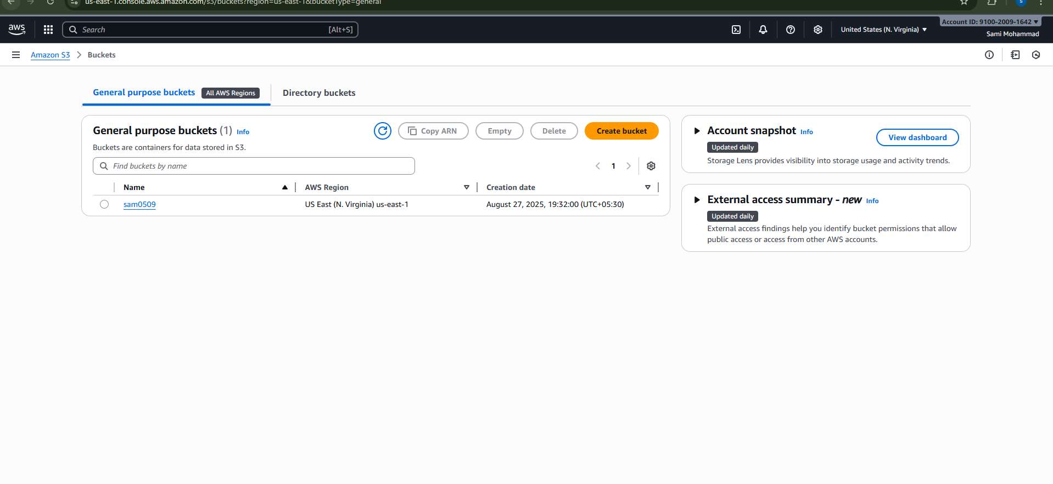
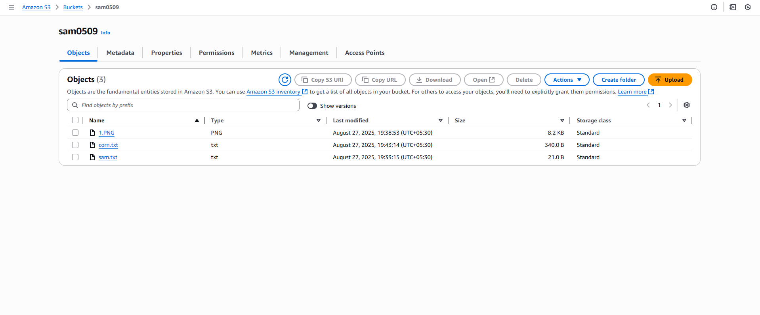
- Deploy static website in s3 bucket.
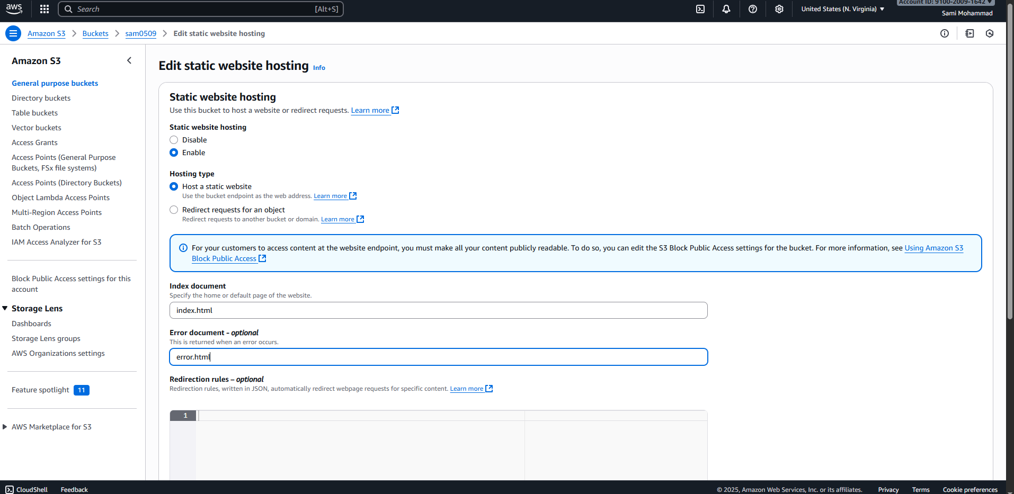
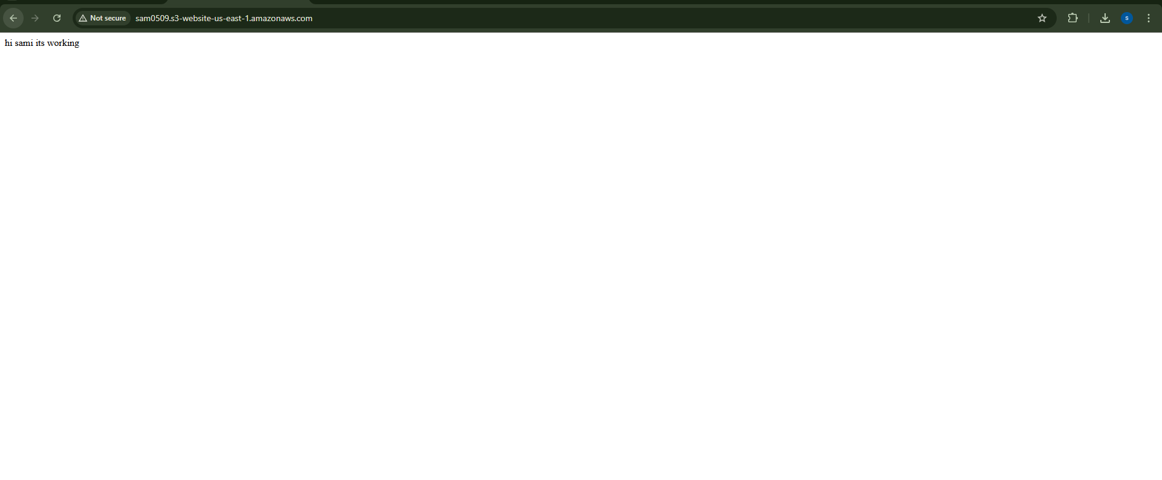
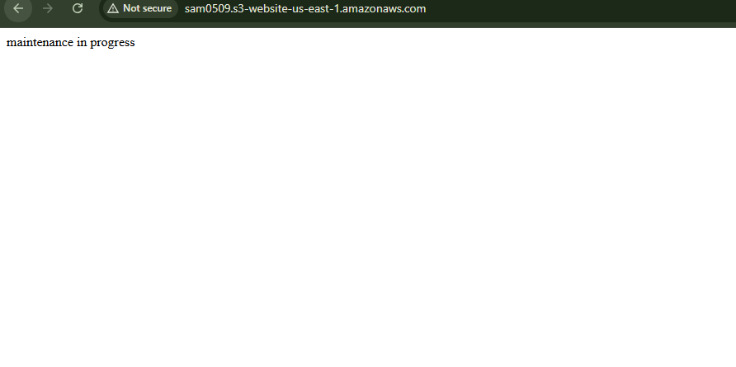
- Enable cross region replication on s3 buckets.
Create two buckets in different region
S3 sam0509 Virginia region
Sam0809 Ohio region
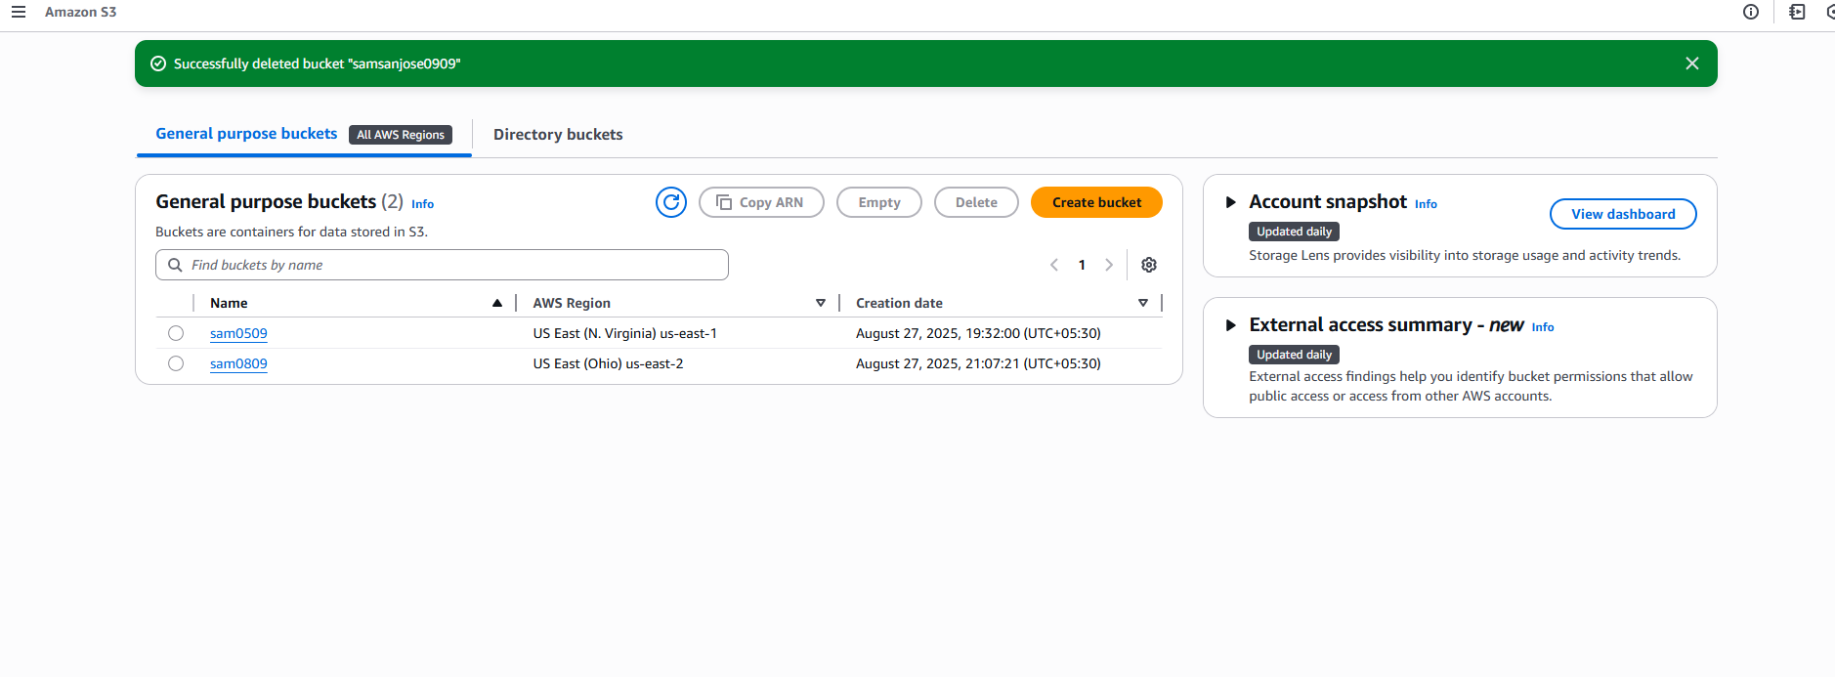
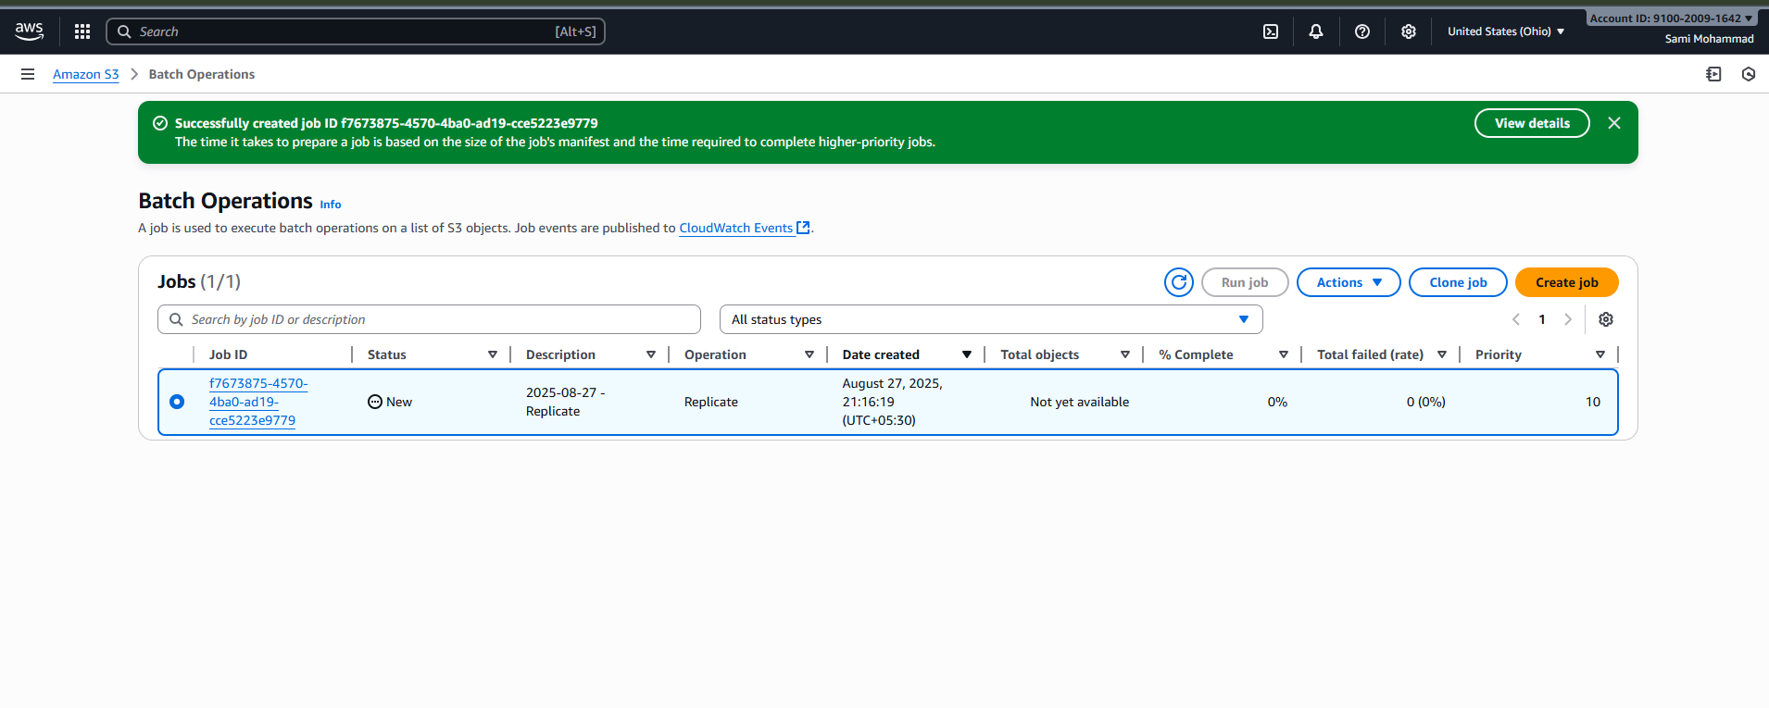
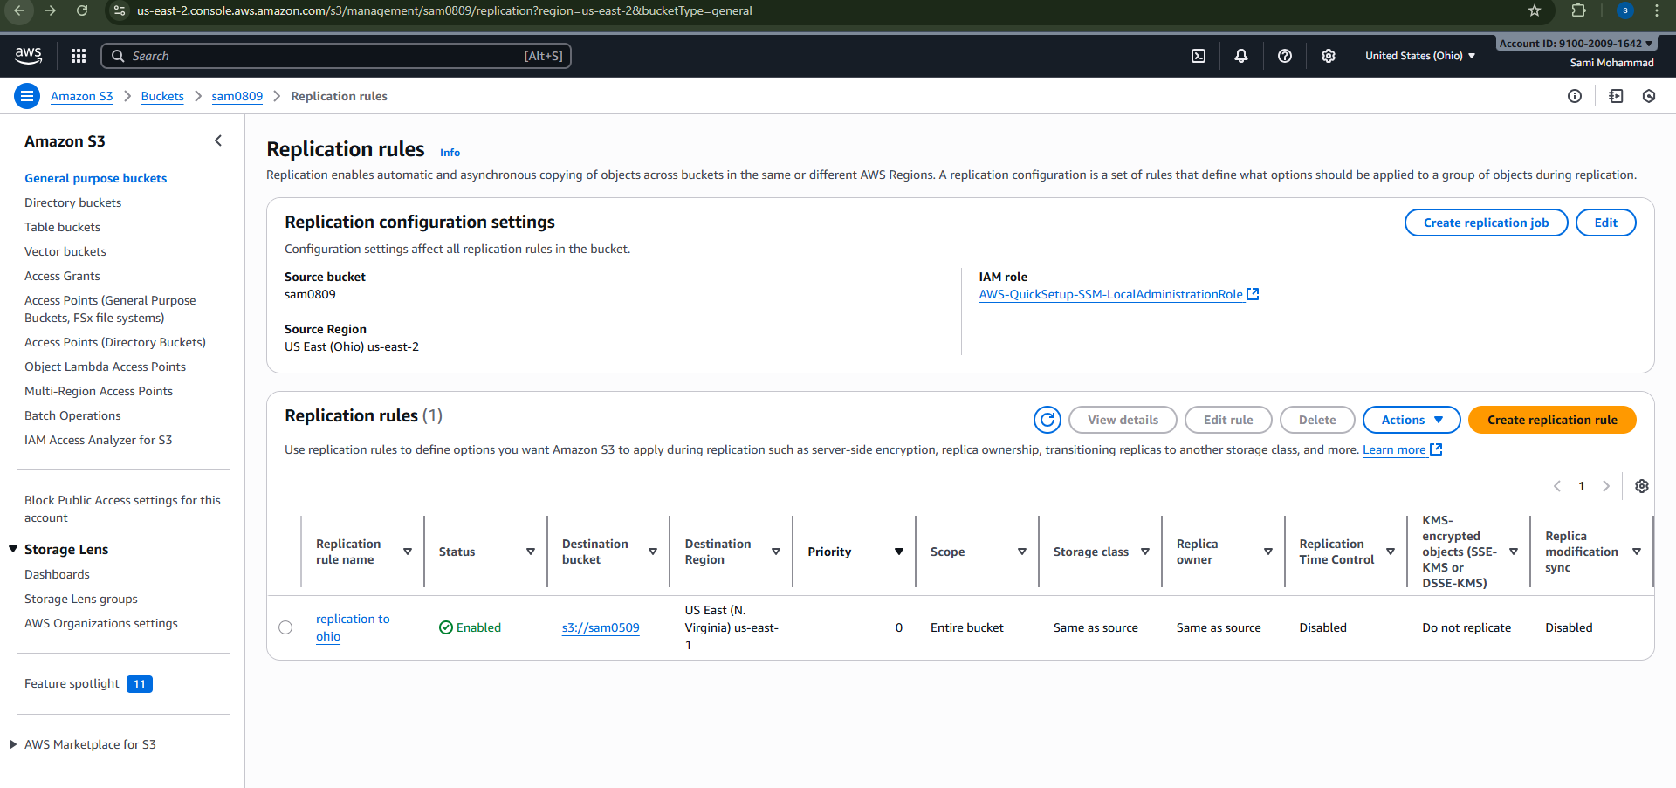

- Configure bucket policy,only Admin user can see the objects of s3 bucket.
S3---> Buckets ---> select created bucket ---> permission ---> edit
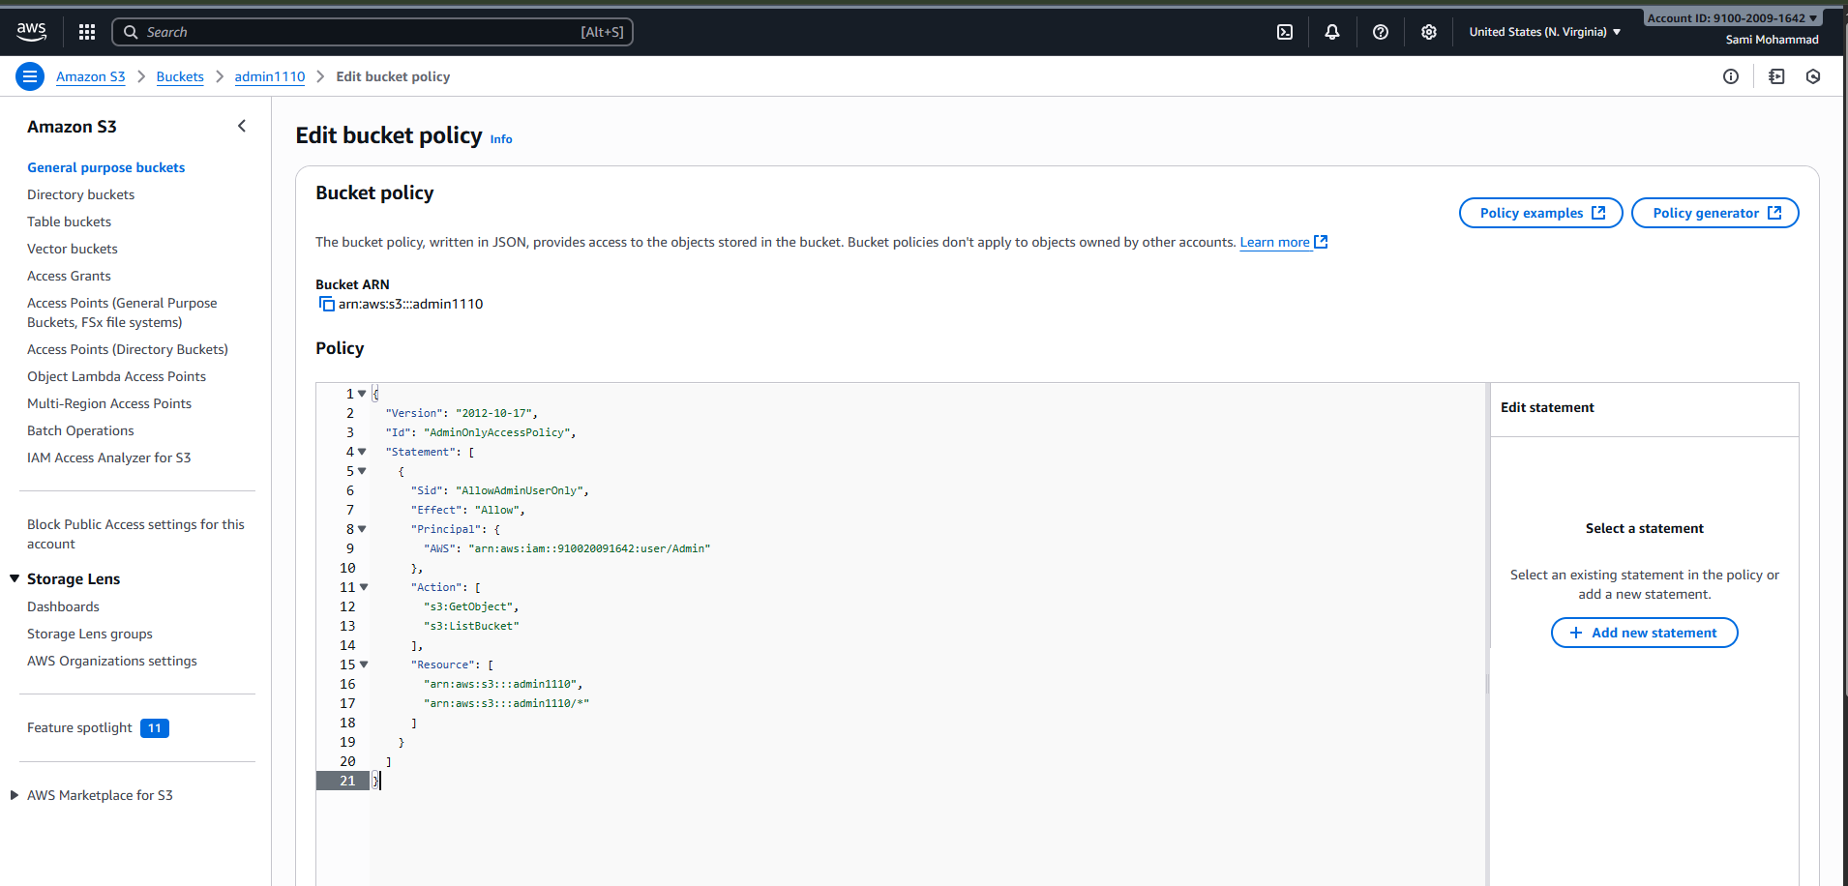
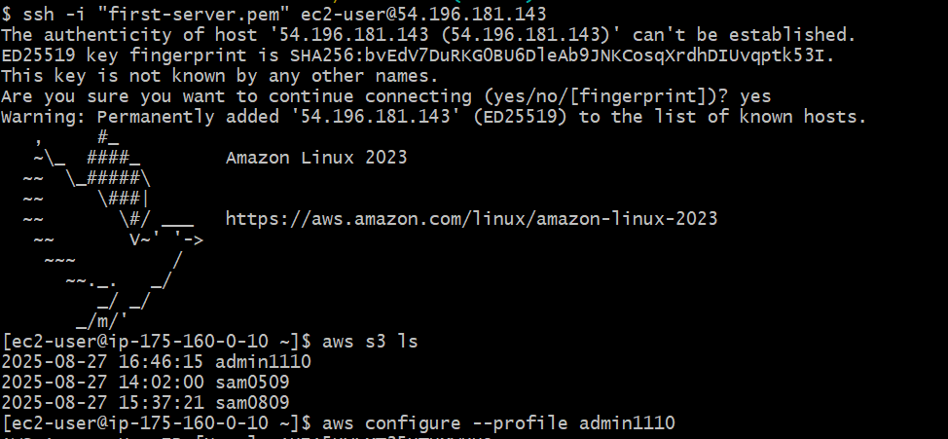
- Setup lifecycle policies to automatically transition or delete objects based on specific criteria.

Amazon s3 ---> Buckets ---> select created bucket ---> Management
---> click Create lifecycle rule
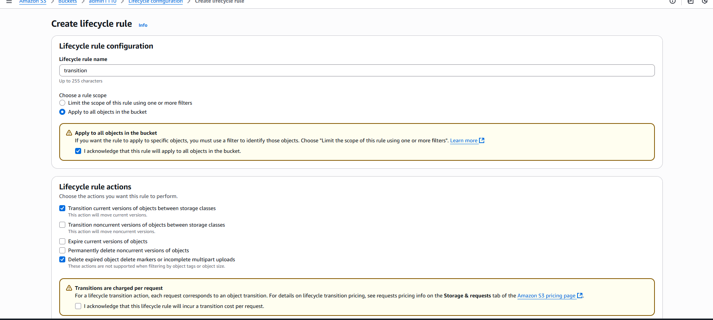
- Push some objects in s3 using AWS CLI.
Create file1
Created file1234.txt
Use command aws s3 cp filename s3://admin1110/ --sse AES256
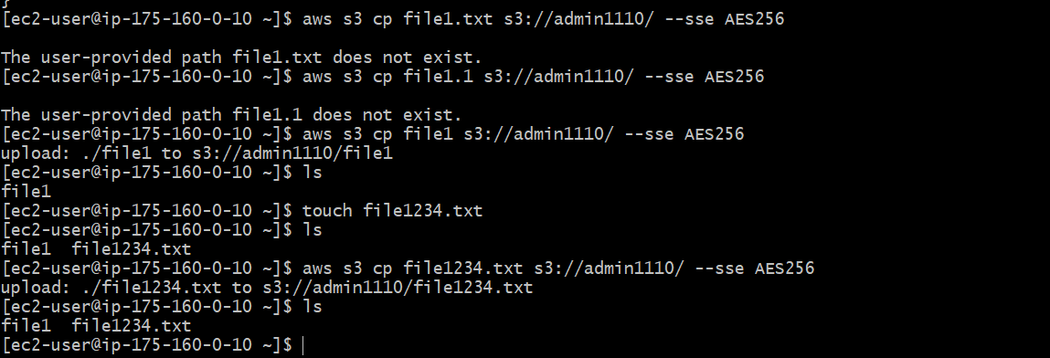
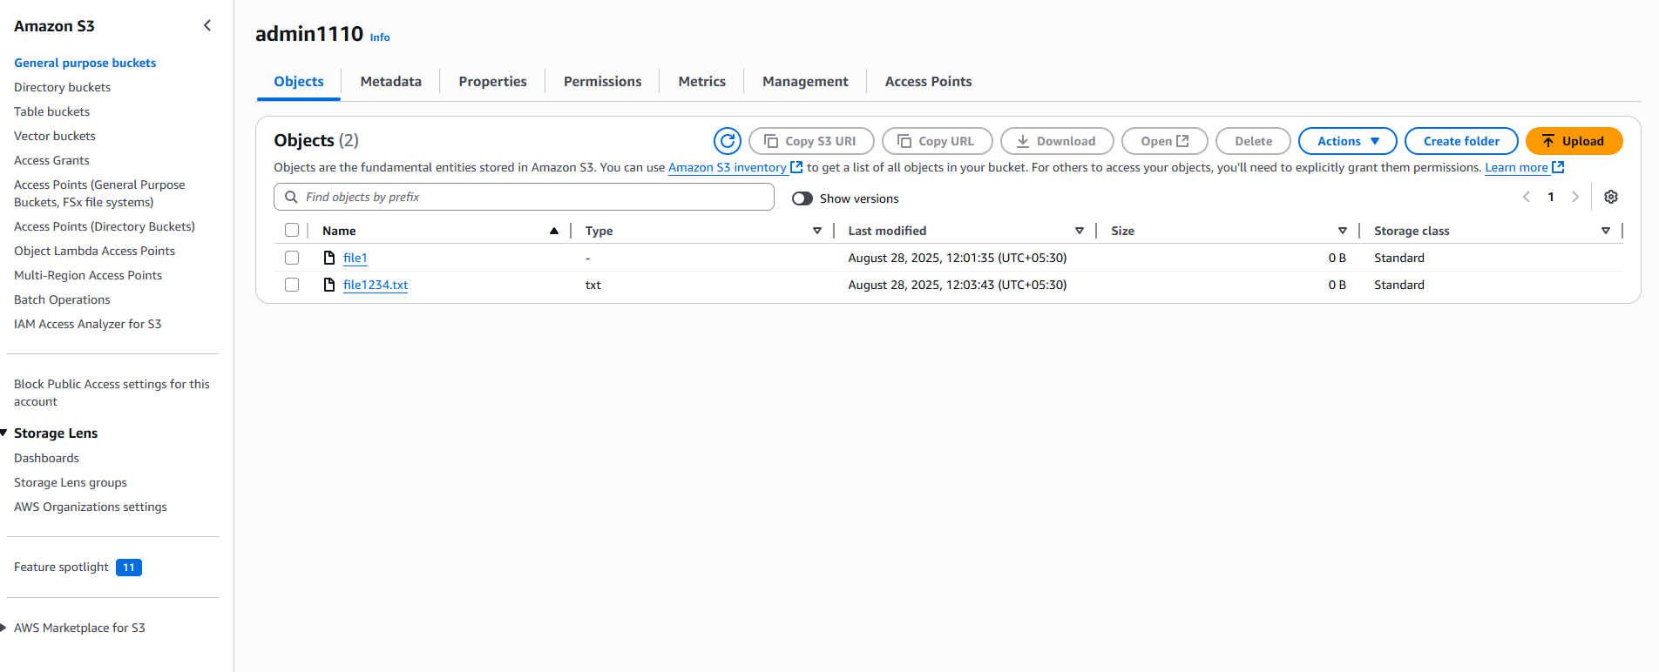
- Write a bash script to create s3 bucket.
Create s3.bash file.

#!/bin/bash
# Variables
BUCKET_NAME="Anam1304"
REGION="us-east-1"
# # Create bucket
aws s3api create-bucket --bucket "$BUCKET_NAME" --region "$REGION"
echo "S3 bucket '$BUCKET_NAME' created in region '$REGION'."

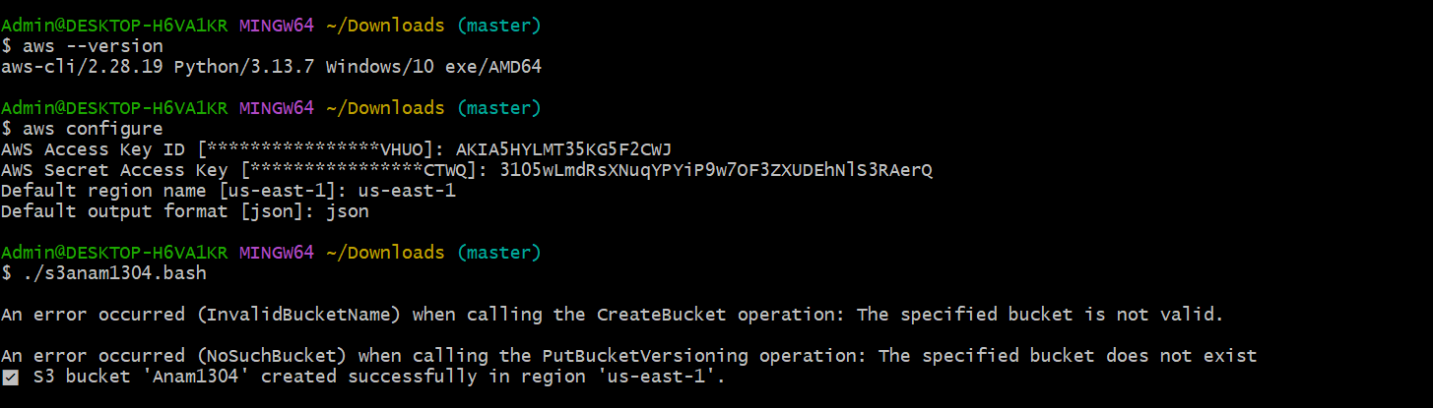

8) Upload one 1 gb of file to s3 using cli.

